A Call for Board Transparency
A Call for Board Transparency
In theory, governing board minutes are meant to be the public’s window into how decisions are made. In practice, what Jerome School District produces is little more than a legal skeleton. The minutes list who was present, which motions were made, and whether they passed. Reports from administrators, such as construction updates, transportation status, or curriculum changes, are often reduced to bullet points with no narrative of what was said, what risks were flagged, or what recommendations were made. For a parent or taxpayer reading after the fact, the “permanent record” is permanently vague.
Jerome does link some attachments to its minutes, but even there the practice falls short. Some attachments are restricted from public access, others are nothing more than additional bullet points with no explanatory detail, and minutes older than 12 to 18 months often have the links and reports completely stripped out. In some cases, reports are missing altogether. For example, the May 2025 Minutes - Superintendent’s Report (Figure 1) shows no attachment and provides no indication of what was presented, or whether anything was presented at all.
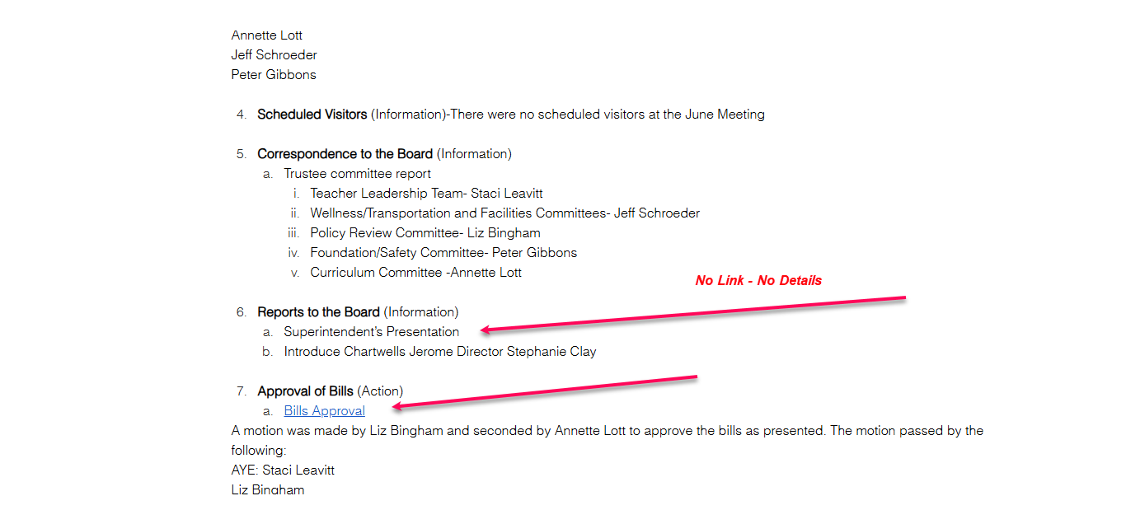
Figure 1: June 2025 Minutes
Even when reports are provided, the level of detail is highly inconsistent. The May 2025 reports make this clear: Federal Programs, Food Service, and Special Services provided thorough, data-driven updates, while the Transportation Director’s May 2025 report was formatted in a narrative style but offered little substantive information, unlike the Federal Programs or Food Service reports that contained detailed data and funding breakdowns. This inconsistency means that some departments provide transparency while others provide little more than promotional summaries.
This appears to be by design, serving as a form of risk management and liability avoidance, and in some cases creating deliberate opacity. Idaho law requires very little in meeting minutes: attendance, motions, and votes. By sticking to that minimum, boards protect themselves from liability. A stripped-down record cannot be used to question a trustee’s reasoning, highlight contradictions, or hold leaders accountable for words spoken in the heat of a meeting. But what is legally sufficient can still be ethically hollow. When reports are reduced to one-line bullets, missing altogether, or stripped of meaningful data, there is no way to connect them to later decisions. A superintendent might present serious safety concerns, and the board might take action, but the official record will never show why.

Best Practice and Legal Standards for Meeting Minutes
While Idaho’s Open Meeting Law doesn’t hold governing boards to a high standard, courts and open-government authorities in multiple states have made clear that minutes must be detailed enough for the public to understand what happened and why decisions were made. For example:
- The Massachusetts Attorney General’s Office, in its official Open Meeting Law Guide, states plainly: “Minutes must include a substantive summary of the discussion on each topic.” It further requires that “minutes should contain enough detail and accuracy so that a member of the public who did not attend the meeting could read the minutes and have a clear understanding of what occurred.” Massachusetts Open Meeting Law Guide, 2025 (PDF) - https://www.mass.gov/doc/open-meeting-law-guide-2025/download
- Likewise, North Carolina law requires even closed-session minutes to “keep a general account … so that a person not in attendance would have a reasonable understanding of what transpired” (N.C. Gen. Stat. § 143-318.10(e)). NC General Statutes Online - https://www.ncleg.gov/EnactedLegislation/Statutes/PDF/BySection/Chapter_143/GS_143-318.10.pdf
- The Reporters Committee for Freedom of the Press (RCFP) highlights this principle in its Open Government Guide, quoting the Ohio rule: “sufficient facts and information to permit the public to understand and appreciate the rationale.” RCFP Open Government Guide – Ohio https://www.rcfp.org/open-government-guide/ohio/
- The National Freedom of Information Coalition (NFOIC) likewise stresses that “meeting minutes should tell the story of the meeting in a way that lets the public know not only what was decided but why.” NFOIC Best Practices
- Washington State Auditor’s Office. (2018). Open Public Meetings Act Best Practices Guide. Olympia, WA. Supplement “action” minutes with recordings, if available. If the agency records the meeting, the recording can be made available to the public along with the action minutes for the benefit of those who desire more detail. https://sao.wa.gov/sites/default/files/2023-11/OPMA-Minutes-Practice-Tips-23.pdf
- New York State Committee on Open Government. (2016). Advisory Opinions on Open Meetings Law. Albany, NY. In my view, above all, minutes are intended to be the official, permanent record of actions taken by public bodies. Their accuracy and completeness are necessary to enable the public to know of public bodies' activities. Equally important, minutes constitute a history of activities upon which public bodies may rely historically, in both the long and short terms, and public bodies often have a need to know of actions they have taken. https://docsopengovernment.dos.ny.gov/coog/otext/o2192.htm
My concern is that Jerome’s current practice, bullet points with no narrative, deliberately withholds the reasoning that matters most. Parents cannot see why decisions were made, why funds were spent, or what risks were acknowledged. When minutes are this thin, and when attachments are inconsistent, restricted, missing, or later removed altogether, the board satisfies the letter of the law while undermining the spirit of transparency. Community members are left guessing at what happened, or chasing down attachments and records through formal requests. The record exists, but it does not inform.
If Jerome wants to rebuild trust after the transportation crisis, one place to start is the minutes. The district should adopt best practices: narrative summaries of reports, contextual explanations for motions, consistent reporting standards across all departments, and full attachments posted online. Transparency is not served by bare legality; it is served by candor, clarity, and records that tell the truth of what happened in the boardroom.

Best Practices vs Jerome School District
Category | Best Practice Recommendations | Jerome School District Practice (from minutes & records)
Legal Compliance | Meets state open meeting laws and goes further by adding context, narrative, and attachments (NSBA, ISBA, ICMA, transparency groups). | Meets only the Idaho Open Meeting Law minimum: date, attendance, motions, votes.
Format of Reports | Narrative summaries (3–5 sentences) of superintendent, financial, and program reports: issue, key findings, implications. Attach supporting documents to minutes. | Bullet points only: “Superintendent gave construction update,” “Special Ed Director gave report.” No narrative of findings or implications.
Board Actions (Motions & Votes) | Record the motion text, context, rationale, and outcome. Include why a policy or contract matters. | Records motion, second, and outcome (“Motion passed”). No explanation of the purpose or impact.
Public Comment | Summarize main themes of citizen comments and how the board responded. | “Audience of Citizens: No requests” or “Public comment taken.” No summaries when comments occur.
Transparency of Reasoning | Ensure someone who wasn’t at the meeting can follow why decisions were made. | Decisions appear disconnected from reports—no written link between the superintendent’s updates and board votes.
Supporting Documents | Attach or hyperlink reports, financials, contracts, and presentations to the minutes. | Some financial reports attached, but many other reports not included. Public often must request them separately. Minutes older than appx 12-18 months, have the attachments / links stripped.
Archiving & Access | Minutes and packets posted online in a permanent, searchable archive. | Historical portal often inaccessible; some records missing or incomplete.
Tone | Neutral, factual, and informative. | Neutral, but overly skeletal—so vague the “permanent record is permanently vague”.

