The Pretext of Security: How Jerome County Tried to Reclassify a Building to Justify a Gun Ban. Was this illegal or Just Unethical?
In government, intent matters. When officials disguise regulatory motives as “security,” they cross the line from governance into manipulation. That line appears to have been crossed in Jerome County, Idaho, in the fall of 2025. A review of county meeting minutes and public reports reveals that county officials were aware they lacked the authority to prohibit firearms in their administrative building but moved forward with a gun ban anyway, citing security and the advice of legal counsel. The result was a brief and legally dubious prohibition that unraveled within days.
The Timeline
September 22, 2025 – The “Emergency Courtroom” Discussion
During a regular Board of Commissioners meeting, County Clerk Cy Lootens raised the idea of designating a room inside the new Jerome County Administration Offices as an “emergency courtroom.” According to the minutes, Lootens told the board that he had already spoken with the Idaho Supreme Court, which informed him the proposal was not legally permissible unless court was held there every day.
That clarification should have settled the question. The state’s highest judicial authority made it clear that the administration building was not a courtroom under Idaho law. The discussion then turned to “building security,” with Lootens suggesting the county “enact security measures” to prevent issues. Commissioners Ben Crouch, Charles Howell, and Art Watkins expressed agreement with moving forward on those security steps. While firearms were not directly mentioned in the minutes, later events revealed that security meant restricting weapons.

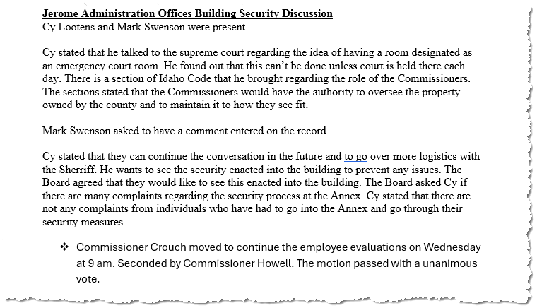
Figure 1: Official Jerome County Commissioner Minutes for September 22nd 2025
September 29, 2025 – The Gun Ban Announcement
One week later, during a meeting at 4:35 p.m., the Jerome County Board of Commissioners voted to prohibit the public from bringing weapons into the Jerome Administration Offices building. The motion was made by Commissioner Watkins and seconded by Chairman Crouch. It passed unanimously, to take effect October 1, 2025. The stated justification was “in light of recent events and in the purpose of protecting employees.”
The minutes show that this action occurred during a section titled “Security Discussion,” following conversations about key card access, after-hours entry, and IT badge controls. There was no public notice, legal memorandum, or open hearing before the vote.
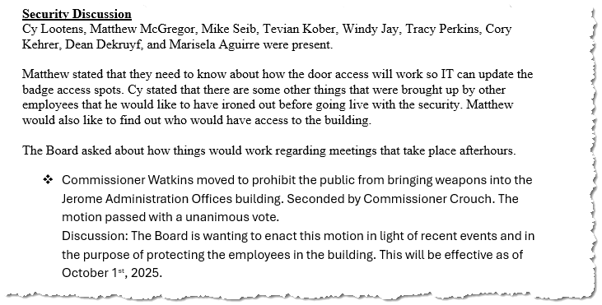
Figure 2: Official Jerome County Commissioner Minutes for September 29th 2025
October 6, 2025 – The Ban Is Repealed
At the next meeting, the commissioners met with County Attorney Mike Seib to review their decision. According to the record, the board stated that they believed legal counsel had told them the restriction was permissible. Seib clarified that the decision “went further than he thought initially to weapons.” The commissioners then acknowledged they may have misunderstood the legal limits and voted unanimously to repeal the ban, apologizing and stating they wanted to fix their mistake and explore other security options.
The same minutes show that the board believed they had acted on Seib’s advice, while Seib distanced himself from the decision. The contradiction is clear: Jerome County officials were told on September 22 by the Idaho Supreme Court that the administration building could not be classified as a courtroom, and on October 6 they were told by their own attorney that the ban exceeded their authority. The only day in between those warnings was September 29, when they enacted the weapons prohibition anyway.
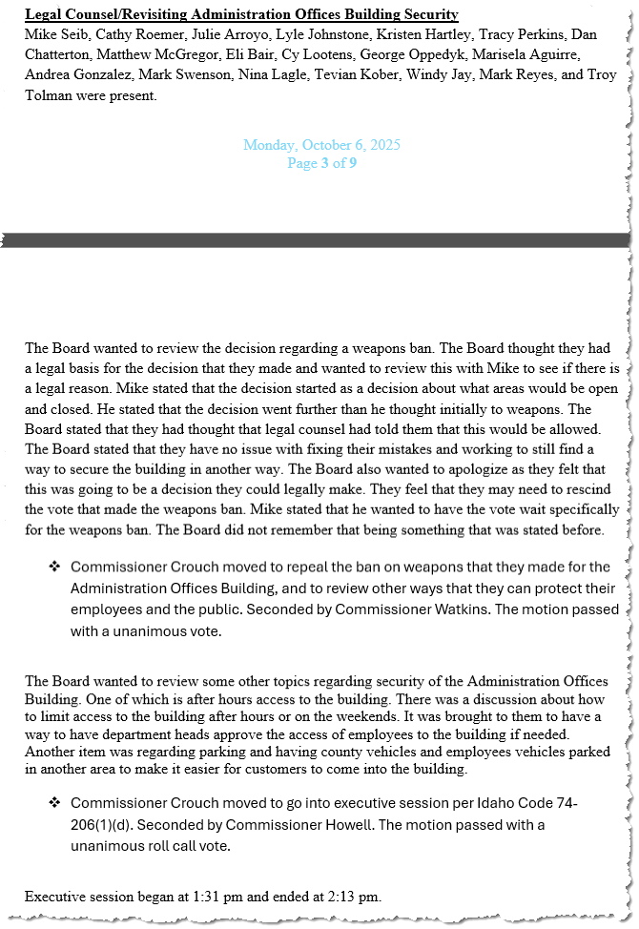
Figure 3: Official Jerome County Commissioner Minutes for October 6th 2025
Legal Implications
Under Idaho Code § 18-3302J, counties are expressly prohibited from creating or enforcing local rules that restrict the possession or carrying of firearms. Proceeding with a ban after receiving notice that the building was not a legally recognized courtroom suggests a willful disregard of state law.
The reliance on “legal counsel” does not excuse the act if that advice contradicted both statute and the Idaho Supreme Court’s prior clarification. If counsel did advise adoption of the ban, that advice itself warrants review. If, on the other hand, the commissioners misrepresented the scope or intent of counsel’s guidance, the ethical fault lies squarely with the board.
The question arises: was this merely a state-level violation or something that implicates federal civil rights under color of law?
Federal “Color of Law” Considerations
Under 18 U.S.C. § 242 and 42 U.S.C. § 1983, officials act “under color of law” when they use government authority to deprive someone of a constitutional right. In this case, that right would be the Second Amendment, applied to the states through the Fourteenth Amendment.
For a federal violation to exist, the action must (1) be done under color of law, (2) deprive a person of a constitutional right, and (3) be willful. The Jerome County ban clearly meets the first criterion, as it was enacted through an official vote. It also meets the second in principle, because it sought to restrict lawful firearm possession by citizens entering a public building not covered by any legal exception. The difficult question is whether the commissioners’ conduct satisfies the third—willfulness.
Because the county rescinded the ban within days, claimed legal misunderstanding, and apparently did not enforce the policy against anyone, it would likely not meet the threshold for criminal prosecution under 18 U.S.C. § 242. There is no record of arrests, removals, or denials of access to the building during the week the ban was active.
However, if any citizen was denied entry, ordered to disarm, or threatened with removal, that individual could pursue a civil claim under 42 U.S.C. § 1983, alleging deprivation of Second Amendment rights under color of law. Even without enforcement, the policy itself created a chilling effect on lawful carry, which courts recognize as a form of constitutional injury.
Thus, while the Jerome County ban may not constitute a prosecutable federal offense, it was still an official act taken under color of law that sought to restrict constitutionally protected behavior. That places it squarely within the framework of civil-rights scrutiny, even if no federal prosecution follows.
Ethical Implications
Ethically, the issue is not limited to the brief existence of a gun ban. It is about transparency, honesty, and the duty of elected officials to act within the law they swear to uphold. The sequence of events demonstrates that Jerome County officials had knowledge of their limitations but advanced the ban anyway, then attempted to justify it afterward as a misunderstanding or legal oversight.
Such behavior undermines public confidence and raises the question of whether “security” was used as a political shield to push through a policy the board already knew was questionable. Government cannot claim ignorance after receiving explicit clarification from the state’s highest court.
The Broader Concern
This incident illustrates how administrative language can be weaponized to expand local authority. By labeling a building an “emergency courtroom,” officials sought to create legal justification for a restriction they could not otherwise impose. If this approach had succeeded, it could have set a dangerous precedent for redefining spaces and powers to bypass state law.
If a county can reclassify an administrative room to justify a gun ban, what stops another jurisdiction from declaring an “emergency assembly zone” to limit protests, or an “emergency media area” to control press access? The principle is the same: manipulating form to seize power that law does not grant.
Questions That Demand Answers
- Who first proposed the “emergency courtroom” designation, and for what purpose?
- Did the county attorney explicitly advise that a weapons ban was lawful, or was this interpretation advanced by commissioners?
- Did the board disclose to legal counsel that the Idaho Supreme Court had already said such a designation would not be valid?
- Were any members of law enforcement consulted before the ban was announced?
- Why did the commissioners state after repeal that they “did not realize they could not do it,” when the Supreme Court’s guidance had already been cited in public minutes?
- What corrective measures will be taken to ensure accurate legal advice and full transparency in future public-safety policies?
Conclusion
Jerome County’s brief 2025 gun ban was not a harmless misunderstanding. The record shows a progression of intent, awareness, and contradiction. The county knew that its building did not qualify as a courthouse, yet moved forward under the banner of “security” and “legal advice.” When confronted, it claimed ignorance. The issue is not whether the ban was short-lived; it is whether it was honest.
Every official involved in this decision had access to the same information: the Idaho Supreme Court’s guidance, the clear language of Idaho Code § 18-3302J, and the limits of county authority. Proceeding in spite of those facts gave the appearance of deliberate disregard for both law and liberty. Such conduct demands public accountability.
If these officials did knowingly act outside the law, they should resign.
Citizens have a right to expect that their leaders will respect both the law and the truth. Until this matter is fully explained, that confidence remains broken.
Disclaimer:
This article is based on publicly available Jerome County Board of Commissioners meeting minutes and related news reports from September and October 2025. All quotations are taken directly from official records. The analysis and commentary that follow represent the author’s interpretation of those public documents and applicable law. Nothing in this article should be construed as a legal accusation, formal allegation of misconduct, or legal advice. Determinations of legality, ethics, or liability ultimately rest with appropriate judicial and oversight authorities. Readers are encouraged to review the original meeting minutes and Idaho Code § 18-3302J for independent verification.

