Economic Development Watch – Resources and Information

Economic Development Watch – Resources and Information
- U.S. Department of Economic Development
https://www.eda.gov/grant-resources/economic-development-directory
- Idaho Department of Commerce
https://commerce.idaho.gov/communities/economic-development-districts-idaho/
- Idaho Economic Development Association
https://www.iedassociation.com/

Idaho Statewide Organizations
- Idaho Economic Development Association
https://www.iedassociation.com
The Idaho Economic Development Association is the statewide professional network for economic-development practitioners. It coordinates training, policy positions, and best practices among cities, counties, regional EDGs, and private partners. It shapes statewide development culture and provides a unified voice for Idaho’s development interests.
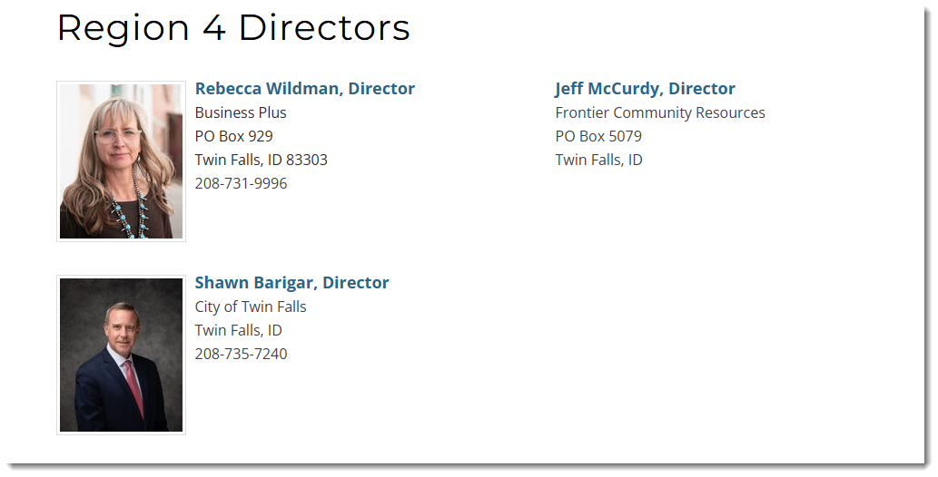
- Idaho Department of Commerce
https://commerce.idaho.gov
The Idaho Department of Commerce administers business incentives, community block grants, rural development programs, and expansion support. It provides the regulatory and financial infrastructure that regional EDGs and local governments depend on to recruit employers and build infrastructure.
- Idaho Department of Commerce – Economic Development Districts of Idaho
https://commerce.idaho.gov/communities/economic-development-districts-idaho/
This directory lists Idaho’s federally recognized Economic Development Districts. It explains their legal authority, regional boundaries, and the requirement to produce federal-compliant economic strategies in order to receive EDA funding.
- Idaho Small Business Development Center
https://idahosbdc.org
The Idaho SBDC provides free business consulting, training, and technical support to small businesses statewide. It supports EDGs by strengthening local business capacity, improving entrepreneurship, and preparing companies for financing and expansion.
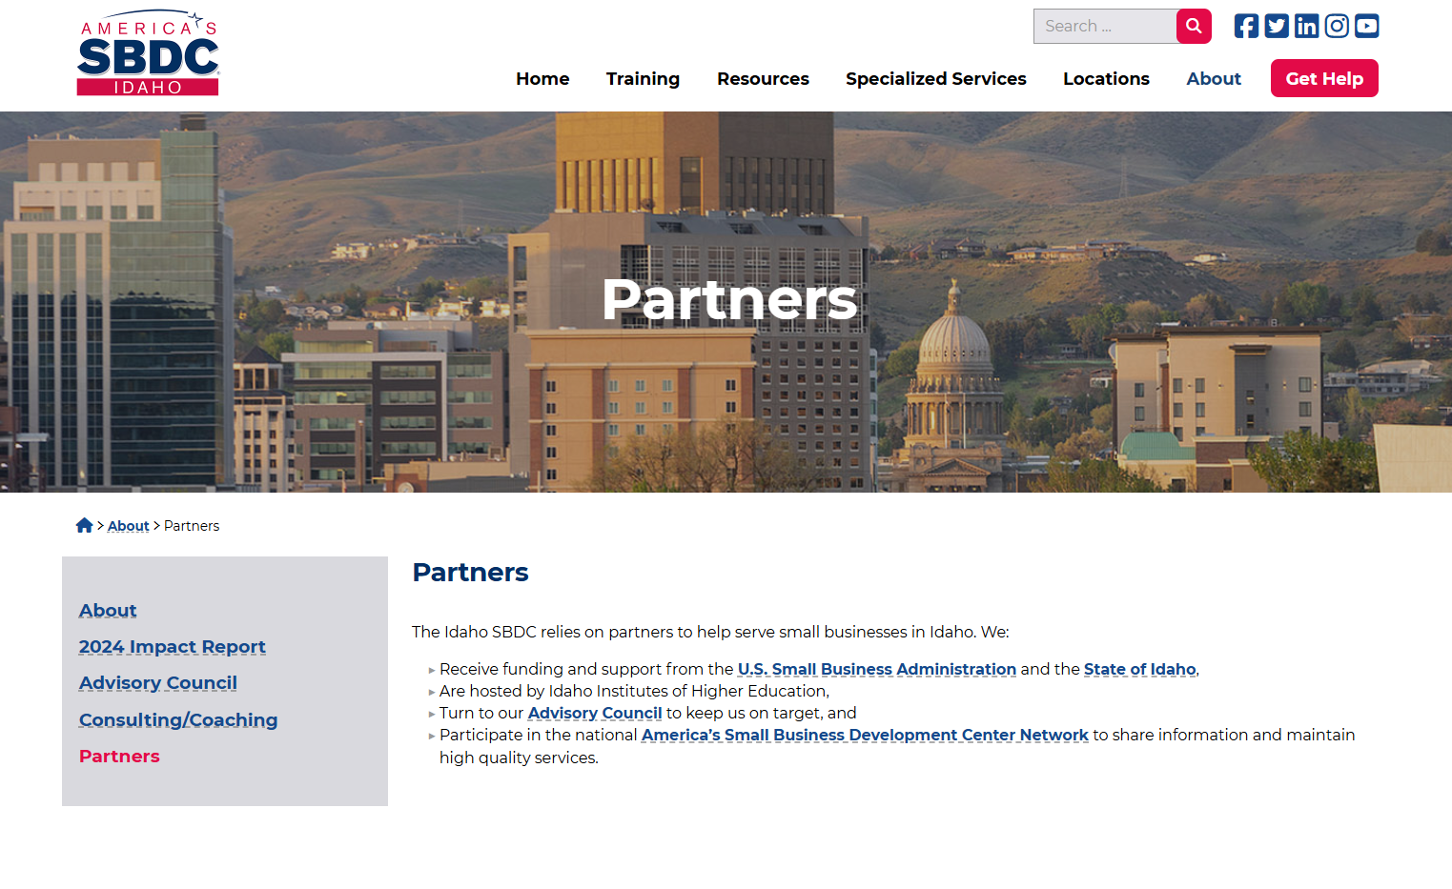

Regional Economic Development Groups (EDDs and Multi-County Organizations)
- Southern Idaho Economic Development
https://www.southernidaho.org
Southern Idaho Economic Development serves Jerome, Twin Falls, Gooding, Lincoln, Minidoka, and Cassia counties. It leads regional recruitment, workforce coordination, and branding efforts that have brought major food processing, manufacturing, and tech employers to the Magic Valley.
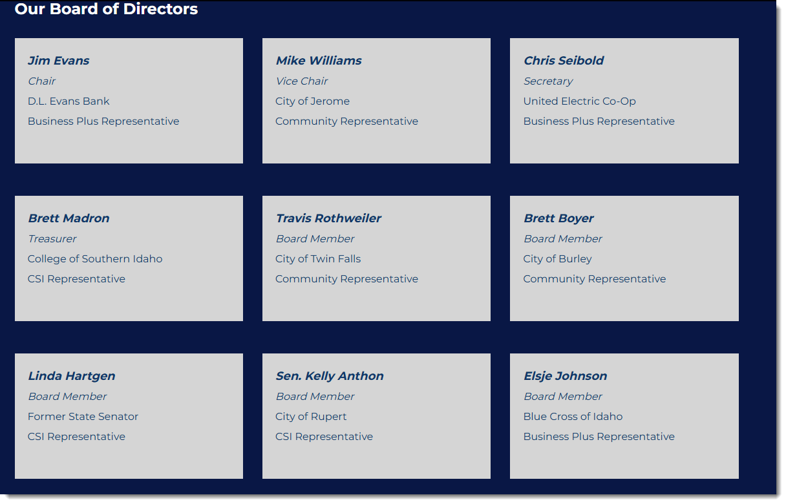
- Business Plus Inc.
https://businessplusinc.org
Business Plus is a private investment group that funds Southern Idaho recruitment and retention efforts. It pools money from local businesses and uses it to support marketing campaigns, recruitment trips, and incentives that help land major employers.
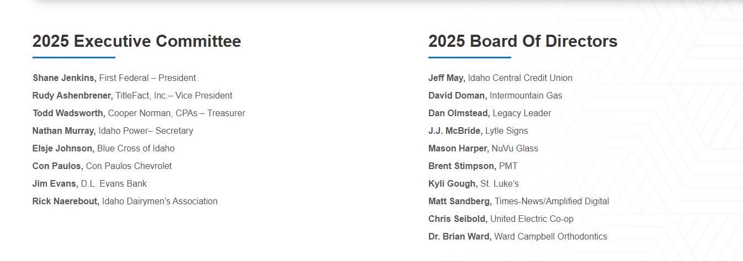
- Boise Valley Economic Partnership
https://www.bvep.org
BVEP is the Treasure Valley’s primary EDG, working across Ada and Canyon counties. It focuses on high-growth industries, corporate relocation, workforce development, and regional branding. It is backed by the Boise Metro Chamber and plays a major role in shaping the Boise metro economy.
- Sun Valley Economic Development
https://sunvalleyeconomy.com
Sun Valley Economic Development operates in Blaine County and the Wood River Valley. It addresses economic diversification, workforce shortages, housing constraints, and seasonal business fluctuations in an area heavily dependent on tourism and hospitality.
- Southeastern Idaho Council of Governments
https://sicog.org
SICOG is a federally recognized Economic Development District serving southeastern Idaho. It manages regional planning, grant administration, housing initiatives, infrastructure coordination, and multi-county development strategies.
- Panhandle Area Council
https://pacni.org
The Panhandle Area Council serves North Idaho through planning assistance, revolving-loan funds, infrastructure finance, grant writing, and development strategy. It plays a major role in funding small-business growth and public works projects.
- Region IV Development Association / Frontier Community Resources
https://frontiercr.org/
RIVDA serves Twin Falls, Jerome, Gooding, and Lincoln counties. It supports rural jurisdictions by providing grant administration, economic strategy development, planning services, and loan programs that strengthen local economies.

- Clearwater Economic Development Association
https://clearwater-eda.org
CEDA is the north-central Idaho development district responsible for regional planning, rural economic development, housing projects, transportation planning, and federal EDA compliance.
- Western Idaho Economic Development Alliance
https://westidahoeda.org
WIEDA unites multiple central and western Idaho counties to recruit employers, coordinate transportation and infrastructure planning, and advocate for rural economic priorities.

Local Economic Development Groups (City and County Level)
- Jerome 20/20 Economic Development Organization
https://jerome2020.com
Jerome 20/20 serves Jerome County and the City of Jerome. It focuses on industrial expansion, downtown redevelopment, workforce partnerships, and recruitment of employers to Jerome’s industrial park and surrounding areas. It operates as a public-private bridge influencing local land-use decisions and long-term growth.
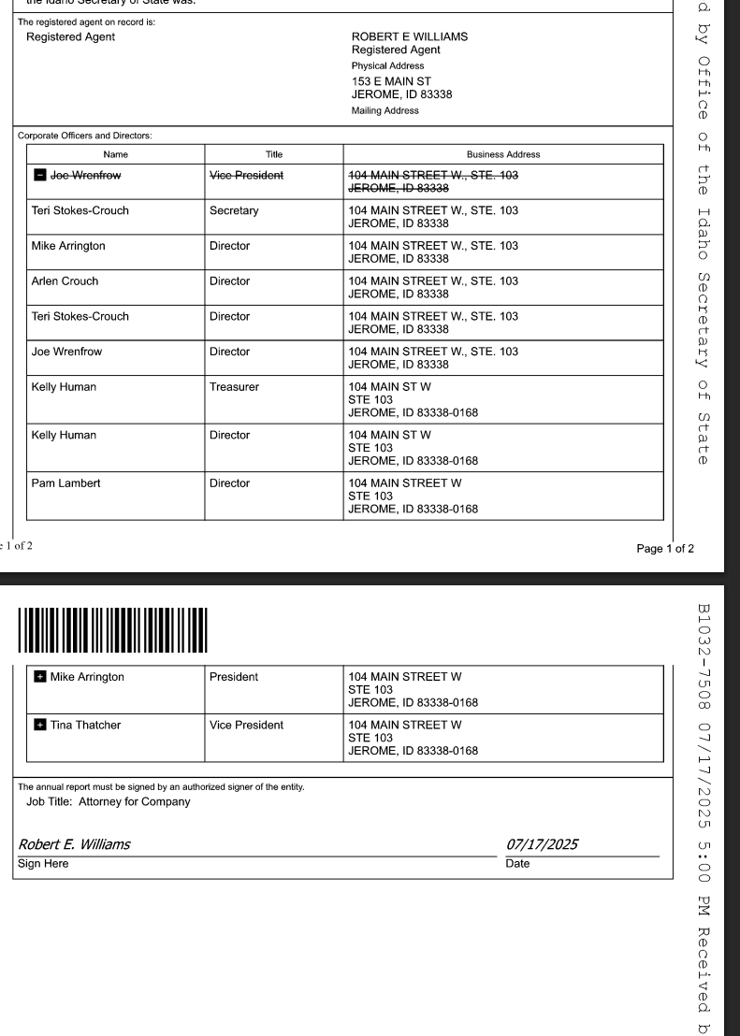
- Lewiston/Valley Vision Economic Development
https://lewistonedc.org
Valley Vision provides economic-development support for Lewiston and the surrounding region. It works to expand manufacturing, logistics, and river-port industries while supporting workforce training and urban revitalization.
- Caldwell Economic Development
https://www.cityofcaldwell.org/government/economic-development
Caldwell’s EDG is tied to the city and its Urban Renewal Agency. It focuses on downtown redevelopment, industrial expansion, agribusiness growth, and housing-supportive infrastructure.
- Nampa Economic Development
https://www.cityofnampa.us/309/Economic-Development
Nampa’s economic-development office supports industrial parks, commercial redevelopment, and workforce initiatives. It works closely with the Nampa URA to revitalize blighted areas and expand infrastructure.
- Twin Falls Economic Development
https://www.tfid.org/201/Economic-Development
Twin Falls supports commercial expansion, industrial recruitment, downtown revitalization, and workforce collaboration. It is a major partner of Southern Idaho Economic Development and coordinates many large-employer projects.
- Idaho Falls Development Services
https://www.idahofallsidaho.gov/116/Economic-Development
Idaho Falls supports industrial expansions, logistics growth, and regional energy-sector development. It collaborates with the Idaho Falls Development Corporation on downtown redevelopment and commercial revitalization.
- Idaho Falls Development Corporation
https://www.renewidaho.org
The Idaho Falls Development Corporation manages tax-increment financing for downtown Idaho Falls and supports urban redevelopment, business attraction, and infrastructure projects in designated renewal districts.
- Pocatello/Bannock Development Corporation
https://bannockdevelopment.org
BDC recruits industrial, logistics, and tech employers to Pocatello and Bannock County. It focuses on airport-related development, rail access, manufacturing, and site-ready industrial land.
- Pocatello Economic Development Services
https://www.pocatello.gov/336/Economic-Development
This office supports local business growth, downtown redevelopment, and mixed-use projects. It works closely with BDC and regional partners to strengthen workforce pipelines.
- Meridian Economic Development
https://meridiancity.org/econdev
Meridian’s development office focuses on commercial growth, urban expansion, transportation planning, and employer recruitment in one of Idaho’s fastest-growing cities.
- Mountain Home Economic Development
https://www.mountain-home.us/economic-development
Mountain Home focuses on aerospace, military-adjacent development, industrial expansion, and downtown revitalization. It works closely with Mountain Home AFB and regional employers.
- Coeur d’Alene Area Economic Development Corporation (Jobs Plus)
https://www.cdachamber.com/economic-development
This group recruits employers to Kootenai County and supports tech, manufacturing, and professional-services growth. It is integrated with the Coeur d’Alene Chamber of Commerce.
- Sandpoint/Bonner County EDC
https://bonnercountyedc.com
The Bonner County EDC supports manufacturing, outdoor-recreation industries, and small-business development. It focuses on rural diversification and local employer retention.
- Payette Economic Development
https://www.cityofpayette.com/departments/economic-development
Payette’s development office assists commercial expansion, small-business support, and infrastructure improvements aligned with downtown redevelopment.

Urban Renewal Agencies (Local Redevelopment Authorities)
- Boise Urban Renewal – CCDC
https://ccdcboise.com
The Capital City Development Corporation is Boise’s redevelopment authority. It uses tax-increment financing to build infrastructure, redevelop blighted areas, and support mixed-use and commercial expansion.
- Nampa Urban Renewal Agency
https://www.cityofnampa.us/242/Urban-Renewal-Agency
The Nampa URA finances street upgrades, downtown revitalization, commercial redevelopment, and mixed-use projects in designated revenue-allocation areas.
- Caldwell Urban Renewal Agency
https://www.cityofcaldwell.org/government/urban-renewal
The Caldwell URA funds downtown revitalization, industrial-park expansion, infrastructure improvements, and redevelopment near the city’s rail and commercial corridors.
- Twin Falls Urban Renewal Agency
https://www.tfid.org/326/Urban-Renewal
The Twin Falls URA directs TIF funding into downtown redevelopment, infrastructure upgrades, and major commercial projects tied to the growth of the Magic Valley.
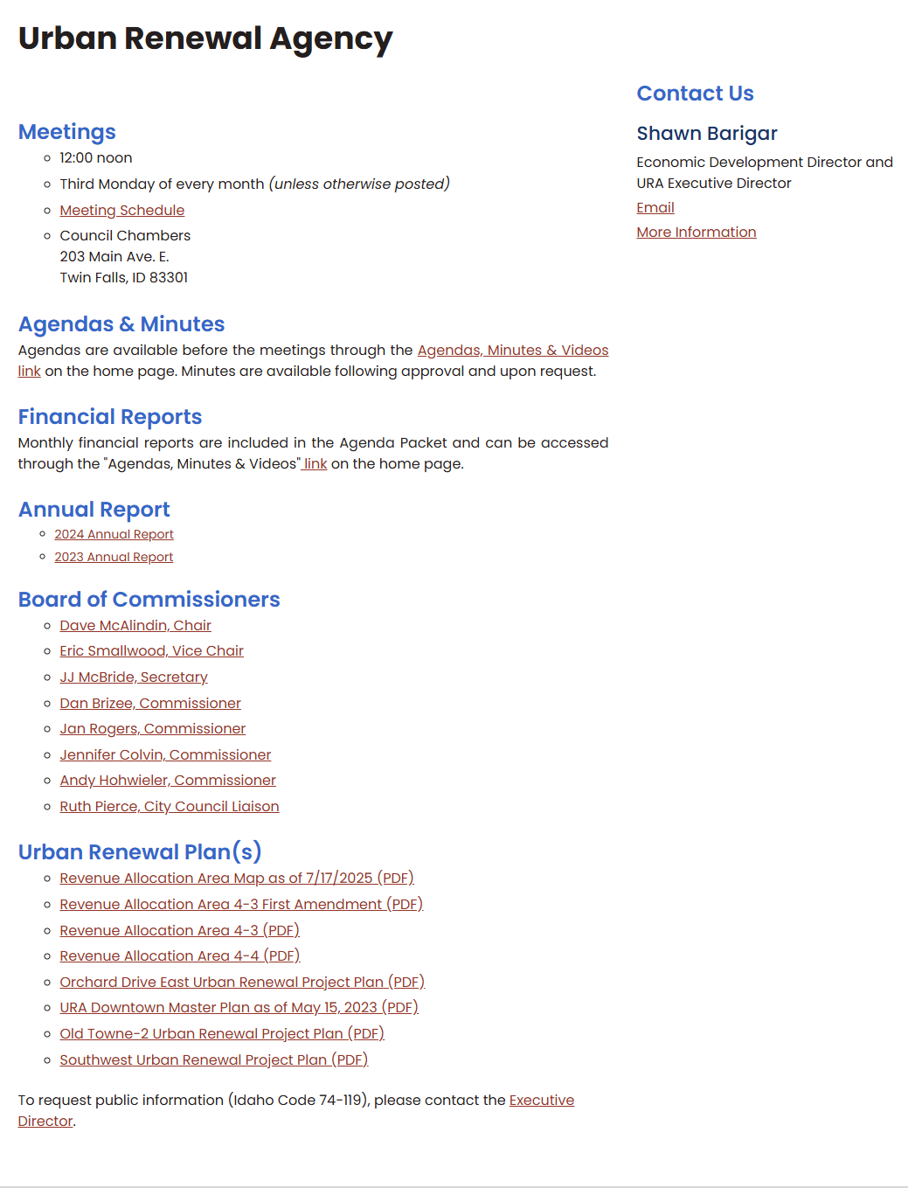
- Idaho Falls Urban Renewal Agency
https://www.idahofallsidaho.gov/326/Urban-Renewal-Agency
The Idaho Falls URA funds redevelopment, infrastructure improvements, and mixed-use development in targeted districts, supporting both commercial expansion and housing.

National and Federal Organizations
- U.S. Economic Development Administration
https://www.eda.gov
The EDA funds and regulates Idaho’s regional development districts and oversees federal planning compliance.
- U.S. EDA – Directory
https://www.eda.gov/economic-development-directory
A national directory of all recognized development districts and regional contacts.
- U.S. EDA – CEDS Guidelines
https://www.eda.gov/ceds
Federal guidelines defining how Idaho’s regional EDGs must create long-term development strategies.
- International Economic Development Council
https://www.iedconline.org
The national association for EDG professionals, setting industry standards and providing training.
- Council for Community and Economic Research
https://www.c2er.org
A national source for labor-market data, cost indexes, and community-development analytics used by EDGs.

Oversight, Research, and Accountability
- Good Jobs First
https://www.goodjobsfirst.org
Tracks corporate subsidies, tax-increment financing, and economic-development accountability nationwide.
- Brookings Institution – Regional Economics
https://www.brookings.edu/topic/regional-economics/
Provides research on industrial policy, regional competitiveness, workforce clustering, and development impacts.
- Idaho Freedom Foundation
https://idahofreedom.org
Provides conservative analysis of tax incentives, subsidies, government expansion, and economic-development schemes.
- Urban Institute – Economic Development and Public Finance
https://www.urban.org
Produces research evaluating the fiscal impacts, effectiveness, and failures of local incentive programs.
- Lincoln Institute of Land Policy
https://www.lincolninst.edu
Researches land-use policy, property taxation, and the hidden public costs of economic-development incentives.

EDG Project Evaluation Checklist
Use this to determine whether a proposed EDG project actually benefits the community or simply shifts risk to taxpayers.
1. Public Cost and Financial Risk
- Does the project require tax incentives, fee waivers, land write-downs, or public financing?
- Does the public assume any financial risk if the company underperforms or leaves?
- Are incentives front-loaded or tied to long-term performance?
- Does the project reduce the tax base for essential services like schools, water districts, and fire protection?
- Has the EDG or county published a full incentive cost breakdown?
2. Job Creation and Workforce Reality
- Are the promised jobs local, or will the company import specialized workers?
- Are wages benchmarked to county median income, not statewide averages?
- Does the project create jobs accessible to existing residents, or only to niche skill groups?
- Does the company’s industry have a history of automation replacing jobs over time?
- Is there a binding requirement for job creation, or only projections?
3. Infrastructure Burden and Long-Term Public Cost
- Does the project require new roads, utilities, substations, water lines, or sewer expansions?
- Who pays for these expansions up front and over the life of the project?
- Does the project strain water supply, wastewater capacity, or fire/EMS services?
- Will the project create ongoing maintenance costs that fall on taxpayers?
- Has the county completed a capacity study for water, wastewater, electricity, and transportation?
4. Land Use and Community Footprint
- Does the project convert farmland, open space, or prime industrial land to private corporate use?
- Does the project align with the county comprehensive plan and future land-use map?
- Is the scale compatible with local government staffing, permitting, and enforcement capacity?
- Does the project affect property values for nearby homes or farms?
- Are there externalities such as noise, traffic, water depletion, or pollution?
5. Transparency and Public Accountability
- Has the EDG released all meeting records, emails, incentive agreements, and cost-benefit analyses?
- Were negotiations conducted publicly or behind closed doors?
- Has the EDG disclosed its donors, board members, and private beneficiaries?
- Does the community have access to progress reporting, benchmarks, and compliance data?
- Are elected officials or EDG leaders financially connected to the project?
6. Company Track Record
- Does the company have a history of tax disputes, environmental violations, or subsidy shopping?
- Has the company abandoned facilities in other states after incentives expired?
- Does the company routinely automate, relocate, or consolidate operations?
- Is the company’s business model stable in a downturn, or is it speculative?
- Is the company privately held, publicly traded, or tied to private-equity firms known for cost stripping?
7. Economic Multipliers and Real Prosperity
- Does the project create secondary economic activity, or is it a closed system (e.g., highly automated facilities)?
- Will local businesses actually benefit, or does the company import all contractors and services?
- Does the project diversify the economy, or deepen existing vulnerabilities?
- Are long-term spending patterns projected honestly, using conservative multipliers?
- Does the project improve upward mobility for residents?
8. Environmental and Resource Impact
- Does the project strain the aquifer, surface water, or irrigation systems?
- Is the water consumption proportional to long-term available supply?
- Does the project produce waste streams that local systems cannot manage?
- Does the facility use high electricity loads that trigger rate increases or require new transmission?
- Does the company commit to monitoring, mitigation, and reclamation?
9. Community Fit and Cultural Impact
- Does the project align with the county’s identity, vision, and long-term goals?
- Will it attract supporting industries that fit the region or change it fundamentally?
- Does it increase housing pressure, rental spikes, or workforce shortages in other sectors?
- Does the company engage locally, or does it operate as an isolated corporate enclave?
- Does the project improve quality of life, or only expand industrial footprint?
10. Exit, Failure, and Enforcement
- Is there a clawback clause requiring repayment of incentives if commitments are not met?
- Is there an enforceable timeline for construction, hiring, and operational benchmarks?
- Can the county revoke incentives for noncompliance?
- What happens to the site if the company leaves?
- Does the project create stranded infrastructure that taxpayers must maintain?

